WEB322 Assignment 2

Submission Deadline:

## Friday, May 26th, 2017 @ 11:59 PM

Assessment Weight:

## 5% of your final course Grade Objective:

## Create and publish a web app that uses multiple routes which serve static files (HTML & CSS). This will serve as the "scaffolding" for future assignments. Specification:

## This assignment will involve creating multiple routes that serve specific HTML pages, styled using CSS.

# **Step 1:** Development Environment

* Create a folder called **web322-app**. This will serve as our main application that we will be updating and modifying throughout this course.
* Inside this folder, initialize a local **Git repository (**using **git init** from the integrated terminal**)** • Add the file **server.js**
* Create a **package.json** file using **npm init**. Ensure that your "entry point" is **server.js** (this should be the default), and "author" is your full name, ie: "John Smith"
* Obtain the **Express.js** module using **npm install express --save**
* **Commit** your changes your **local git repository** (using the source control icon displaying a (**99+**) icon) with the message "initial commit"

# **Step 2:** Adding Files / Folders

* 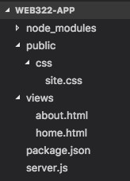Add the folder **views** - this will be the location of the .html files that we will be using in our application
* Add the folder **public** - this will be the location of the .css, client side .js & image files that we use in our application
* Inside the **views** folder, add the files **home.html** and **about.html**
* Inside the **public** folder, add the folder **css**
* Inside the **public/css** folder - add the file **site.css** (this will serve as the main .css file for our app)
* Your folder structure should now look like the image to the right:

# **Step 3:** Quick Modification of Files

* Before starting on your **server.js** file, add some content to **home.html**, **about.html** and **site.css,** ie**:**
* **home.html:**

<!doctype html>

<html>

<head>

<title>Home</title>

<link rel="stylesheet" href="css/site.css" type="text/css" />

</head>

<body>

<h3>Home</h3>

</body>

</html>

* **about.html**

<!doctype html>

<html>

<head>

<title>About</title>

<link rel="stylesheet" href="css/site.css" type="text/css" />

</head>

<body>

<h3>About</h3>

</body>

</html>

* **style.css**

h3{

color: red; }

# **Step 4:** Update server.js & testing app

• Now that all the files are in place, update your **server.js** file according to the following specifications (**HINT**: Refer to the sample code from **week 2** for reference):

* The server must make use of the "**express**" module o The server must listen on **process.env.port** **|| 8080**
* The server must output: "Express http server listening on ***port***" - to the console, where ***port*** is the port the server is currently listening on (ie: 8080)
* The route "**/**" must return the **home.html** file from the **views** folder o The route "**/about**" must return the **about.html** file from the **views** folder
* **NOTE**:for your server to correctly return the "css/site.css" file, the "**static**" middleware must be used: in your **server.js** file, add the line: **app.use(express.static('public'));** - we will discuss this in greater detail in

Week 4 o From the integrated terminal, enter the command **node server.js** and verify the following:

* + The integrated terminal shows "Express http server listening on 8080"
  + The url: **http://localhost:8080** shows the text "Home" in red
  + The url: **http://localhost:8080/about** shows the text "About" in red

# **Step 5:** Updating Views

• Now that we have verified that the server is functioning properly, we need to update our views to show something a little more like a real website: o **home.html**

* + Update your **home.html** file to use the HTML & CSS from the **2-column layout** from **WEB222** (located here: https://scs.senecac.on.ca/~patrick.crawford/shared/winter2017/web222/lecture9/pt2/layout-2-column-grid.html ).
  + **HINT:** right-click on the page and choose "**View Page Source"**
  + **NOTE**: Any CSS present on the HTML page (between <style> tags) must be placed into your own **views/css/style.css** file.
  + Change the <title> element to read "Home"
  + Change the links in the <nav> element from "**Seneca College**", "**ICT**" and "**Google**" to "**Home**" (url: "/") and "**About**" (url: "/about")
  + Change the top heading to read "myApp" instead of "HTML5 Structural Elements"
  + Update the left column <h3> element to read "Coming Soon" and add a short message to the user.
  + Update the right column <h2> element to read "Welcome"
  + Update the <footer> element to read **© 2017 - Student Name** (where "Student Name" is your name)
  + When completed, the page should look like:

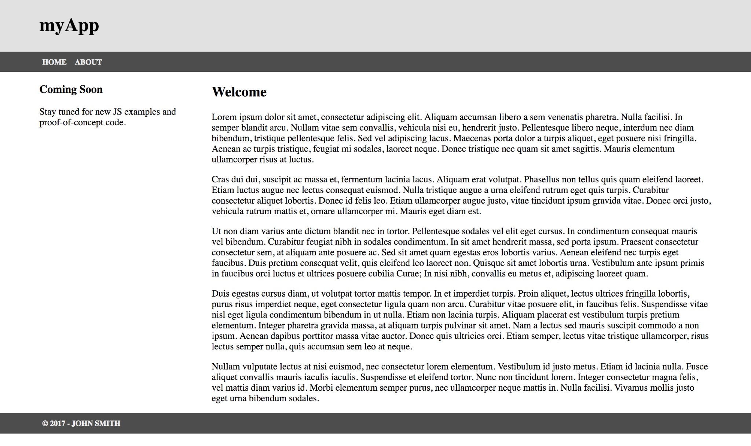

o **about.html**

* Update your **about.html** file to use the HTML & CSS from the **1-column layout** from **WEB222** (located here: https://scs.senecac.on.ca/~patrick.crawford/shared/winter2017/web222/lecture9/pt2/layout-1-column-grid.html ).
* **HINT:** right-click on the page and choose "**View Page Source"**
* **NOTE**: Any CSS present on the HTML page (between <style> tags) must be placed into your own **views/css/style.css** file (this should be the same as "home.html").
* Change the <title> element to read "About"
* Change the links in the <nav> element from "**Seneca College**", "**ICT**" and "**Google**" to "**Home**" (url: "/") and "**About**" (url: "/about")
* Change the top heading to read "myApp" instead of "HTML5 Structural Elements"
* Change the <h2> element in the main column (<article> element) to read "***FirstName LastName***

- the developer" where FirstName and LastName are your first Name & Last Name

* Update the <footer> element to read **© 2017 - Student Name** (where "Student Name" is your name)
* Write a short blurb 추천 광고 about yourself, ie what year you're in, what you would like to do when you have graduated, etc.
* When completed, the page should look like:

o **style.css**

* Feel free to update **style.cs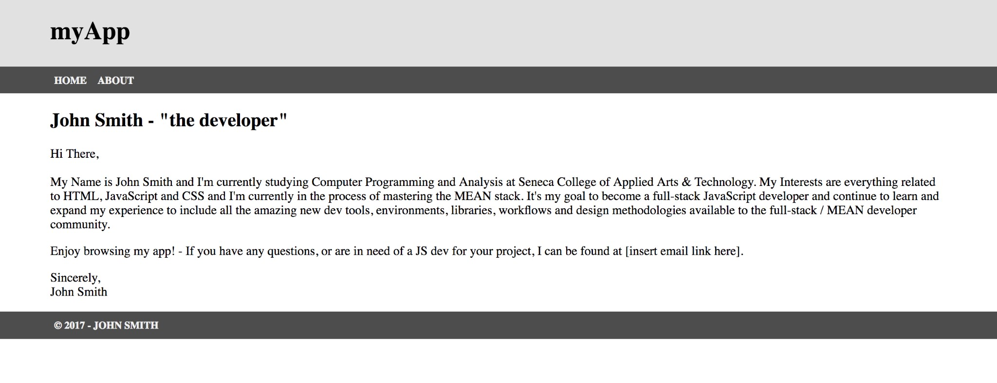s** to provide additional style to the pages in your app. Black, White and Gray is boring, so why not add some cool colors and fonts (maybe something from Google Fonts)?

# **Step 6:** Pusing to Heroku

* Once you are satisfied with your application, deploy it to Heroku:

o Ensure that you have checked in your latest code using **git** (from within Visual Studio Code) o Open the integrated terminal in Visual Studio Code o Log in to your Heroku account using the command **heroku login** o Create a new app on Heroku using the command **heroku create** o Push your code to Heroku using the command **git push heroku master**

* **IMPORTANT NOTE:** Since we are using an "**unverified" free** account on Heroku, we are limited to only **5 apps**, so if you have been experimenting on Heroku and have created 5 apps already, you must delete one (or verify your account with a credit card). Once you have received a grade for Assignment 1, it is safe to delete this app (login to the Heroku website, click on your app and then click the **Delete app…** button under "**Settings**").

Assignment Submission:

* Add the following declaration at the top of your **server.js** file:

## /********************************************************************************* * WEB322 – Assignment 02

## * I declare that this assignment is my own work in accordance with Seneca Academic Policy. No part * of this assignment has been copied manually or electronically from any other source * (including 3rd party web sites) or distributed to other students.

## *

## * Name: ______________________ Student ID: ______________ Date: ________________

## *

## * Online (Heroku) Link: ________________________________________________________

## *

## ********************************************************************************/

* Compress (.zip) your web322-app folder and submit the .zip file to My.Seneca under **Assignments** -> **Assignment** 2 Important Note:
* **NO LATE SUBMISSIONS** for assignments. Late assignment submissions will not be accepted and will receive a **grade of zero (0)**.
* After the end (11:59PM) of the due date, the assignment submission link on My.Seneca will no longer be available.